easy fish cakes
Ingredients
1 pack of fish pie mix or 350g of chosen fish
3 spring onions – chopped
100ml milk
450g potatoes – peeled
75g frozen sweetcorn – defrosted
Handful of grated cheddar cheese
1 eggs – beaten
Plain flour – for dusting
Olive oil – for frying

Credit – bbc good food
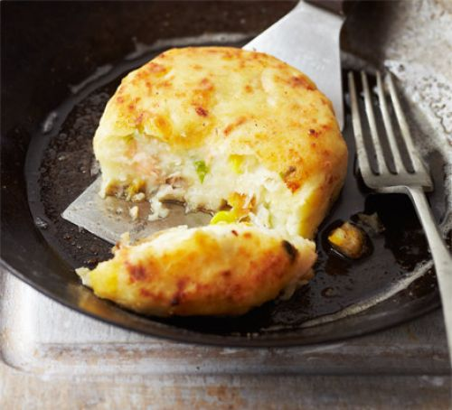
Serves 4-6 | Prep Time: 15 mins | Cook Time: 30 mins

Method
- Cook the potatoes in boiling water until just tender.
- Drain well and return to the pan on a low heat and heat for another 2 mins to evaporate excess liquid.
- Mash the potato with a small piece of butter and then allow to cool.
- Put the fish, spring onions and milk in a shallow dish. Cover with cling film and microwave for 2 mins until just cooked.
- Drain the fish and spring onions through a fine sieve.
- Gently mix the potatoes with the fish and onions (try not to break up the fish too much) along with the sweetcorn, cheddar and some black pepper.
- When the mixture is cool, form into 6-8 patties.
- Pour the egg on one place and scatter flour on the other. Dip the patties in egg and then flour and arrange on a sheet of baking paper on a baking tray.
- Put the patties in the fridge for half an hour to firm up – you can also freeze them at this point.
- Heat a large frying plan with a generous glug of olive oil and then the oil is hot, ask an adult to lower the fish cakes (1 or 2 at a time) into the pan and cook for 5-7 minutes on each side or until golden brown and heated all the way through.
- Serve with some chips and vegetables or you can eat them as a snack!

