frozen banana lollies
Ingredients
2 bananas
4 large strawberries
100g natural yoghurt
200g dark chocolate
1 tbsp sprinkles of your choice
4 wooden lolly sticks

Credit – bbc good food
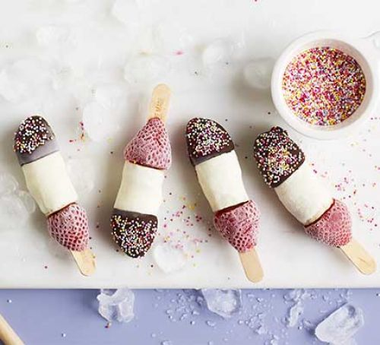
Serves 4 | Prep Time: 10 mins | Cook Time: 5 mins

Method
- Peel the bananas and chop the ends off. Then chop them into 4 equal sized chunks.
- Poke a strawberry onto each lolly stick first, then push on a piece of banana.
- When all your banana pops are made, lay them on a plate and put in the freezer uncovered for 1 hour.
- Put the yoghurt into a tall glass or jug then dip each banana pop into the yoghurt to coat just the banana – leave the strawberries.
- Place the pops back on the plate and refreeze until set.
- Melt the chocolate in the microwave in 30 second bursts (stirring after each blast) then pour into a mug.
- Dip the strawberry end into the dark chocolate the quickly sprinkle your choice of toppings before the chocolate sets.
- Refreeze and then serve. These can be kept in the freezer for up to 1 week.

