peanut butter and jam flapjacks
Ingredients
5 tbsp salted butter
250g crunchy peanut butter
8 tbsp jam of your choice
80g light soft brown sugar
200g rolled oats

These are great recipe to get involved with using ingredients you may already have in your cupboard!

Credit – bbc good food
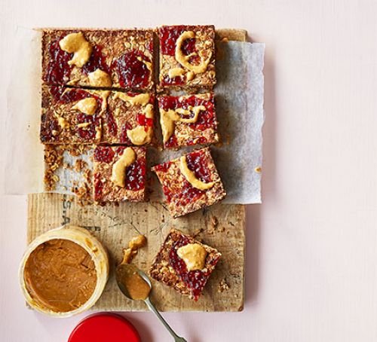
Makes 9 | Prep Time: 15 mins | Cook Time: 30 mins

Method
- Heat the oven to 180C or gas mark 4.
- Butter and line the base of a square cake tin with baking paper.
- Put 3 tbsp of the peanut butter and jam in separate small bowls and set aside.
- Tip the remaining peanut butter, jam and butter into a pan on a medium heat and stir until it’s all melted together.
- Quickly stir in the oats and then leave to cool for 5 minutes.
- Spoon the mixture into the prepared cake tin and gently press down with your hands.
- Dot the left over jam and peanut butter over the mixture and bake in the oven for 20-25 mins or until golden brown.
- Leave to completely cool in the tin, then turn out onto a board or plate and cut into squares.

