quick tomato soup with cheesy garlic dippers
Ingredients
400g can of cherry tomatoes
1 tbsp caster sugar
100ml vegetable stock
1 tsp Worcestershire sauce
2 tbsp mascarpone
FOR DIPPERS
Ciabatta rolls or other bread (halved)
1 garlic clove (halved)
125g grated cheese

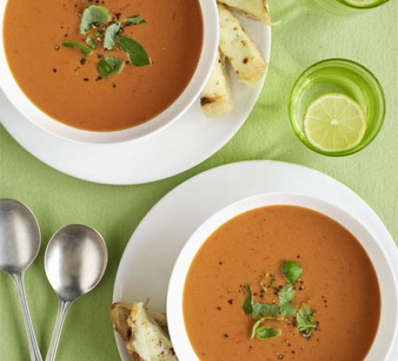
Credit – bbc good food
Serves 2 | Prep Time: 10 mins | Cook Time: 20 mins

Method
- Put the tomatoes, sugar, stock and Worcestershire sauce in a medium pan with some salt and pepper.
- Bring to a simmer and cook for 5-10 minutes.
- Stir in the mascarpone and them blend until smooth either with a hand blender or in a food processer in batched and return to the pan to keep warm.
- Heat the grill to high and toast the ciabatta or any bread you have chosen until golden.
- Rub each slice with the garlic, sprinkle with some salt and then top with the grated cheese and grill until melted and the cheese is bubbling and golden.
- Slice the bread into fingers and serve with the soup.
- This soup can also be frozen if you have any left over or have made a larger batch.

